FSDI 104 – Final Report
Name: Charles Taggart
Theme: Object Constructor
GitHub Pages Link: https://github.com/chucktagg83/project104.git

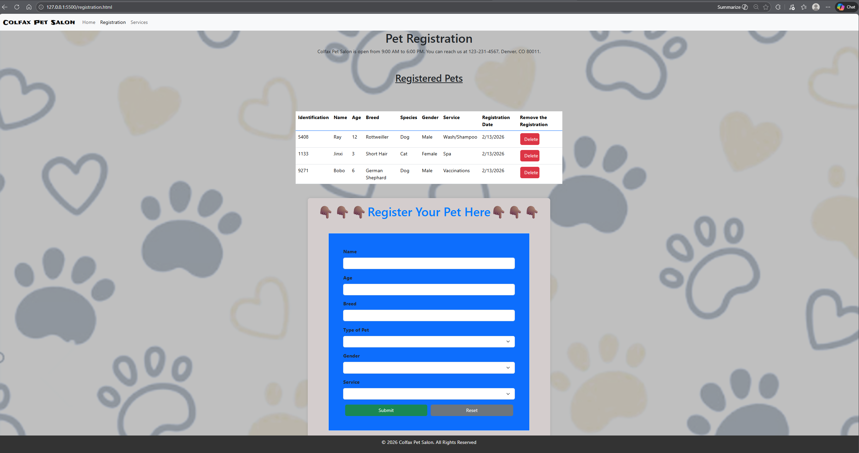
Summary of Edits:
- Tested all functions and confirmed they all worked.

